Person-to-Person (P2P)

👤 What Is Person-to-Person (P2P) SMS?
# Source: Chatgpt (GPT-5-Mini) at [1/21/2026]
P2P SMS stands for Person-to-Person Short Message Service.
It refers to text messages that are sent directly between two mobile users, using their phones.
💬 It’s what you do when you send a normal SMS to a friend, family member, or colleague.

📱 Example Scenarios:
# Source: Chatgpt (GPT-5-Mini) at [1/21/2026]
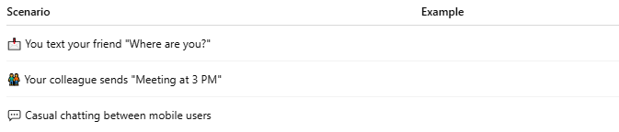

Scenario | Example
📩 You text your friend "Where are you?"
🧑‍🤝‍🧑 Your colleague sends "Meeting at 3 PM"
💬 Casual chatting between mobile users
These are all P2P SMS — real people typing and sending messages directly.

🧩 How P2P SMS Works:
# Source: Chatgpt (GPT-5-Mini) at [1/21/2026]
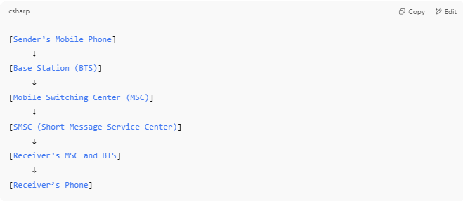

[Sender’s Mobile Phone]
↓
[Base Station (BTS)]
↓
[Mobile Switching Center (MSC)]
↓
[SMSC (Short Message Service Center)]
↓
[Receiver’s MSC and BTS]
↓
[Receiver’s Phone]

- The message is sent via the SMS Center (SMSC).
- If the recipient is offline, SMSC stores and forwards it later.
- HLR/VLR help locate the recipient for proper delivery.

🆚 P2P vs A2P SMS:
# Source: Chatgpt (GPT-5-Mini) at [1/21/2026]
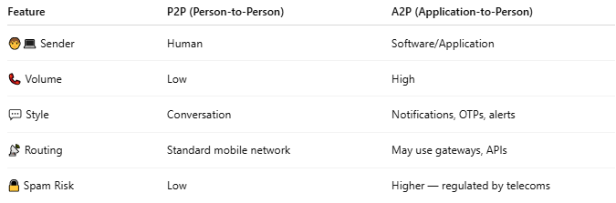

Feature | P2P (Person-to-Person) | A2P (Application-to-Person)
🧑‍💻 Sender | Human | Software/Application
📞 Volume | Low | High
💬 Style | Conversation | Notifications, OTPs, alerts
📡 Routing | Standard mobile network | May use gateways, APIs
🔒 Spam Risk | Low | Higher — regulated by telecoms

✅ Characteristics of P2P SMS:
# Source: Chatgpt (GPT-5-Mini) at [1/21/2026]
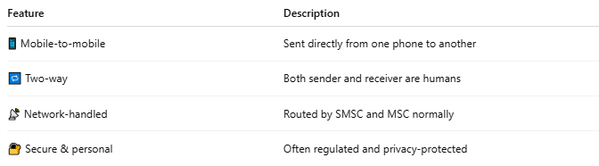

Feature | Description
📱 Mobile-to-mobile | Sent directly from one phone to another
🔁 Two-way | Both sender and receiver are humans
📡 Network-handled | Routed by SMSC and MSC normally
🔐 Secure & personal | Often regulated and privacy-protected

📖 Summary:
# Source: Chatgpt (GPT-5-Mini) at [1/21/2026]
P2P SMS is:
- 💬 The regular texting you do with friends or family
- 🧍↔️🧍 Sent from one mobile user to another
- 📡 Routed using standard mobile infrastructure (SMSC, MSC, BTS)
- 🆚 Different from A2P, which is automated and high-volume

